SIMATS ENGINEERING (SAVEETHA SCHOOL OF ENGINEERING)
Course Code & Title: | ECA5604 -5G/6G COMMUNICATION | Course Faculty: | Dr.K.Sathish
Student Name: | Velamuri Bhanodhay | Reg. No.: | 192412330
Dept / Batch: | BE.ECE / 2024 | Date: | 15/7/2026
Lab Observation

Experiment 2 : Implementing TDMA Slot Allocation in GSM.

Objective 1: To calculate the Time Slot Duration in a GSM TDMA frame by dividing the total frame
time into equal time slots. This helps in understanding the time structure of GSM
communication.

Matlab Code:

clc;clear
t=0:4.615/8:4.615; y=ones(size(t));

subplot(211)
stem(t,y,'filled')
grid on
title('TDMA Time Slot Structure')
xlabel('Time (ms)'),ylabel('Slot Level')

subplot(212)
plot(t,y,'-o')
grid on
title('Continuous View of Slot Allocation')
xlabel('Time (ms)'),ylabel('Slot Presence')

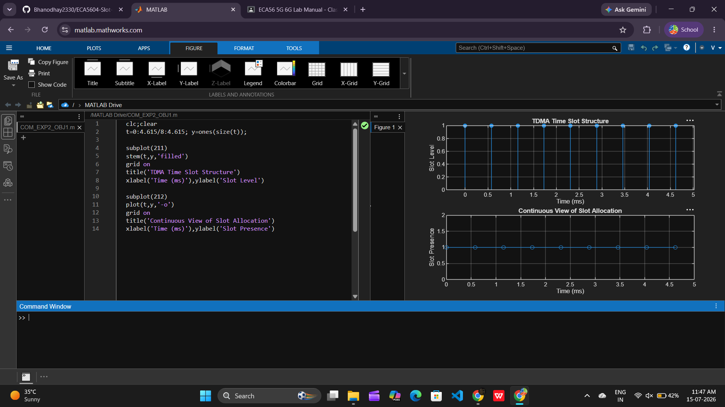

Objective 2: To determine the Frame Utilization (%) based on the number of allocated time slots
compared to total available slots. This evaluates the efficiency of TDMA resource usage.

Matlab Code:

clc;clear
A=6; F=8-A;

disp('Frame Utilization (%)')
disp(A/8*100)

subplot(211)
plot([1 2],[A F],'-o')
grid on
title('GSM Frame Utilization (Allocated vs Free)')
xlabel('Slot Type Index (1=Allocated, 2=Free)')
ylabel('Number of Slots')

subplot(212)
pie([A F])
title('Slot Distribution in GSM Frame')
legend('Allocated','Free')

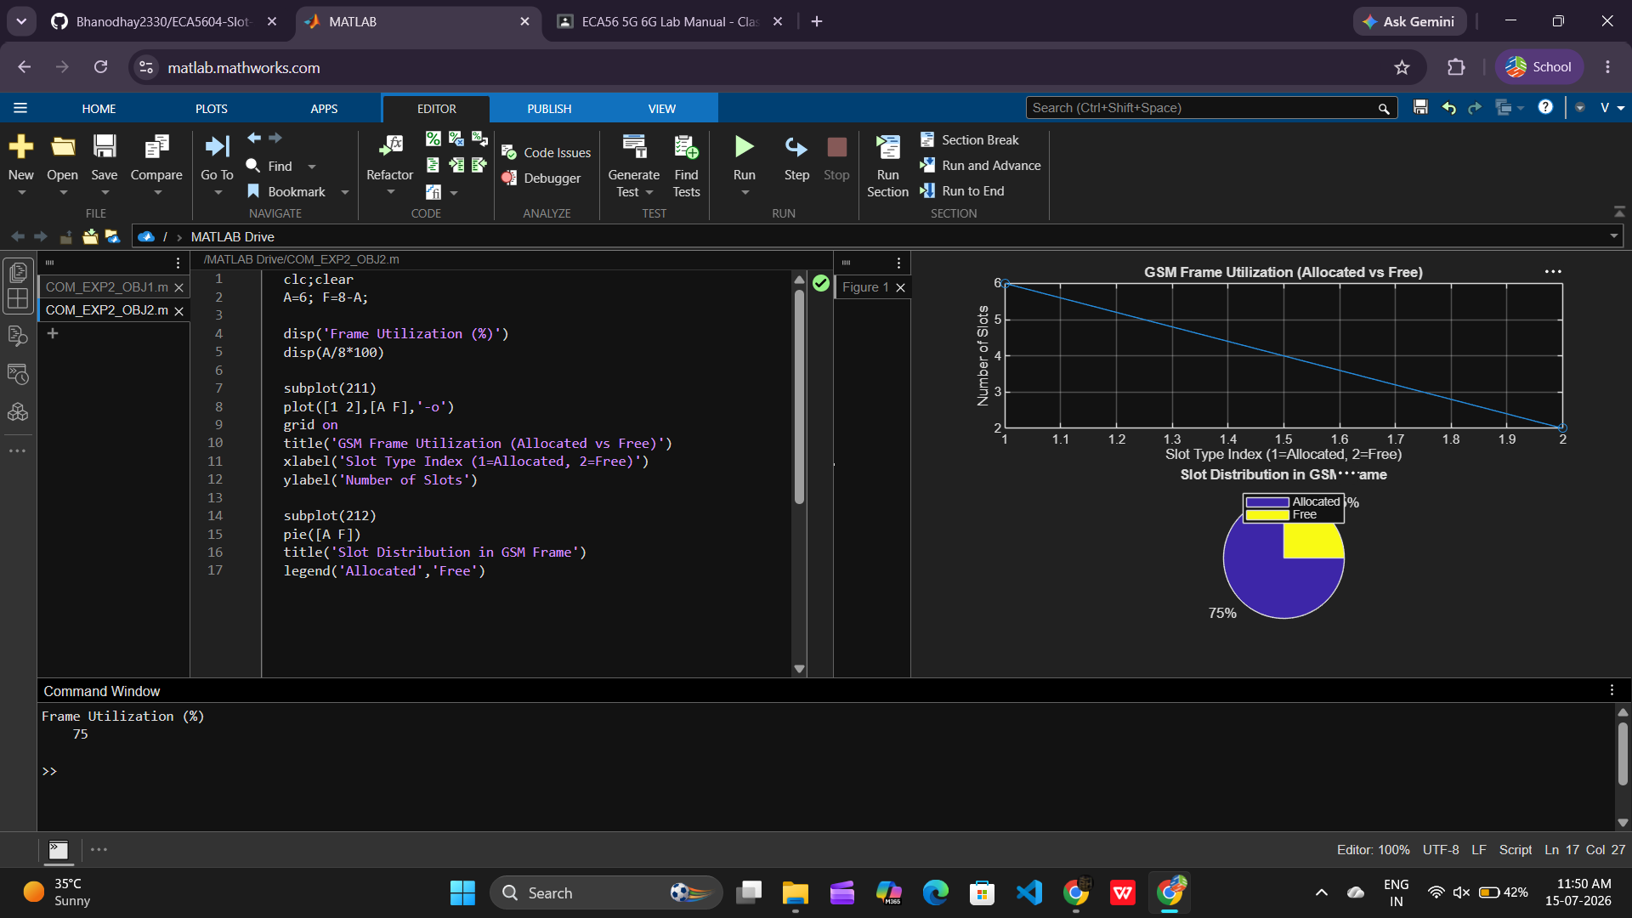

Objective 3: To compute the Number of Allocated Time Slots for multiple users in the GSM system.
This ensures proper scheduling and interference-free communication.

Matlab Code:

clc;clear
U=1:8; A=[ones(1,5) zeros(1,3)]; B=1-A;

disp('User Wise Slot Allocation')
disp(table(U',A','VariableNames',{'User','Status(1=Allocated,0=Blocked)'}))

subplot(211)
stem(U,A,'filled')
grid on
title('TDMA Slot Allocation per User')
xlabel('User Index'),ylabel('Slot Status (1=Allocated, 0=Blocked)')
ylim([-.2 1.2])

subplot(212)
plot(U,A,'-o',U,B,'-s')
grid on
title('TDMA Slot Utilization Analysis')
xlabel('User Index'),ylabel('Status')
legend('Allocated','Blocked')

